System functions
Functions that are not related to a specific module or channel are called system functions and most are accessible from the status bar of the home page. In this section the following functions will be discussed:
- Event viewer
- Tracking
- File manager
- User profiles
- Power outputs coupling
- Display lock / unlock
- Power / Reset control
- User SW
Event viewer  During operation, EEZ BB3 will record the time of events of certain user activities, as well as events that require user attention (i.e. warnings and errors). Events are saved in an event log that can be accessed by tapping the event view icon. The number of events stored in the event log is limited only by available space on the SD Card.  The appearance of a new event that requires user attention and occurred after the last review of the event log will result in a change in the color of the icon. | 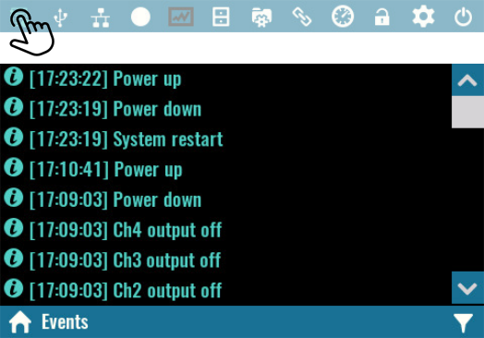

If SD card is not present or dysfunctional only the latest 50 events will be accessible via Event viewer. That events will not be written to non-volatile memory, and will be lost after the restart.

Events filtering
Four types of logged events exists and their appearance in the event viewer depends of the selected filter. The Debug filter represents the most comprehensive view that contains all type of events will Error filter allows appearance of error messages. | 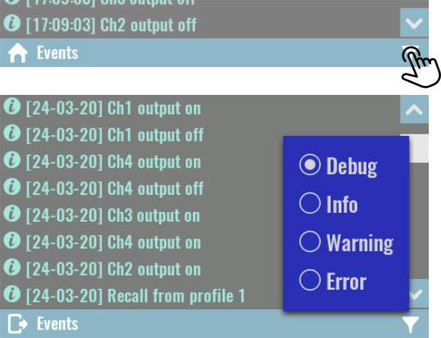

Events types identification is simplified by using different icons and colors. | 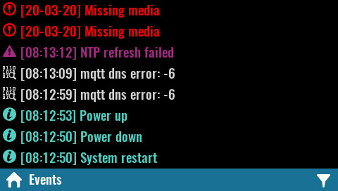

If the content of the message cannot be displayed in one line due to its size, an expansion option will appear. | 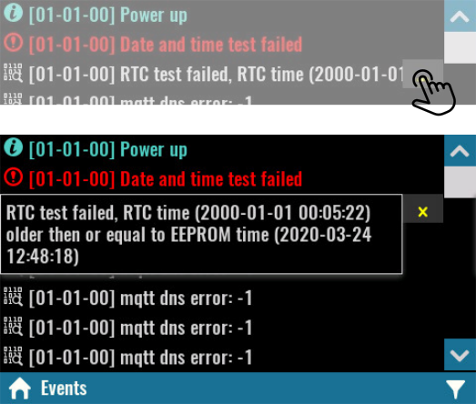

Tracking  Tracking is a convenient way to manage two or more channels simultaneously, i.e. there is no “master-slave” configuration, when changes can only be made via the master channel.  Only one tracking group can be set up. Channels that are in the tracking group will be able to define the following parameters at the same time:  - Output set current and limit  - Output set voltage and limit  - Output power limit  - OCP, OVP, OTP and OPP parameters (activity, delay, status) | 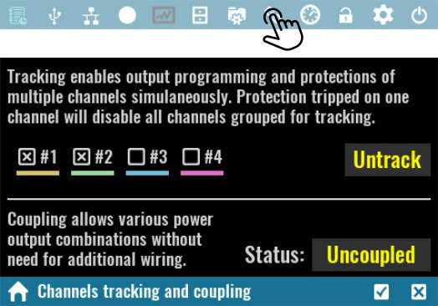
- Tripped protection clear
- Trigger type, source and delay
- Output list definitions (dwell, current, voltage)
When channels are in a tracking group, some of their options will be disabled (e.g. calibration). The Untrack option can be used for clear selections and will become visible only if two or more channels are selected.

SCPI
OUTPut:TRACk[:STATe] (@<chanlist>)

File manager  File manager lets you access and work with files on a SD card. The working data is organized into multiple folders (directories) as follows:  - Scripts – contains MicroPythons scripts (.py files) and related resources (.res files )  - Screenshots – contains all screenshots taken (see User SW)  - Recordings – data logging function use this folder to store recorded data | 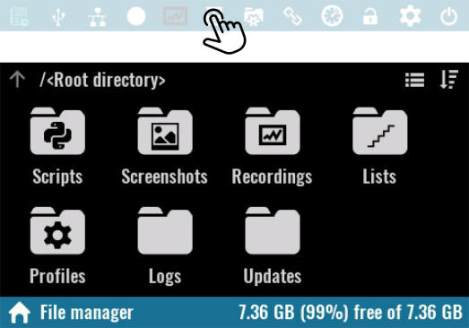
- Lists – contains program lists that can be executed on the selected channel
- Profiles – location for user profiles
- Logs – recorded events that are accessible via Event viewer.
- Updates – contains firmware binary images that can will can be selected from module’s firmware download section.

Folders and files in File manager can be displayed as list. | 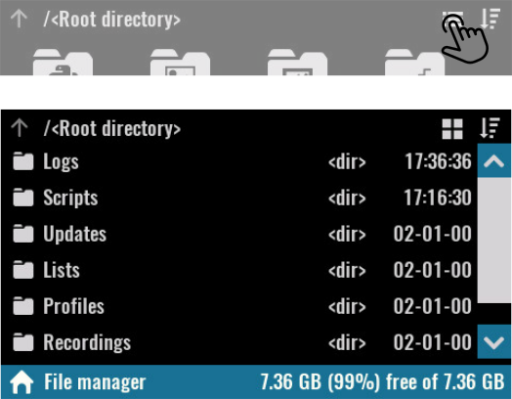

Files and folders displayed can be sorted by name, size and time in descending order and ascending order. Selecting the Sort icon will display a menu through which you can select the sorting method.  SCPI  MMEMory:CATalog?  MMEMory:CATalog:LENgth?  MMEMory:INFOrmation?  MMEMory:TIME? {<filename>} | 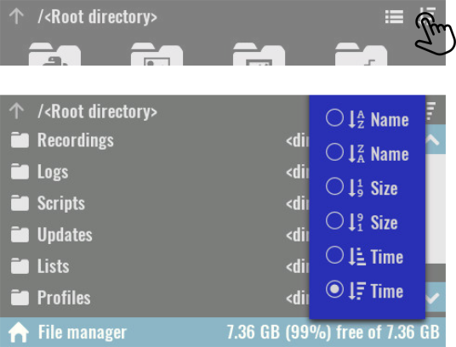

Clicking on a file name will open a menu whose options will be enabled or disabled depending on the file type and whether a computer connection is established.  Open  Displays an image in .jpg format, or opens a viewer for logged data in .dlog format  Upload  Initiates file transfer to the computer. If the file is large, the progress percentage will be displayed. | 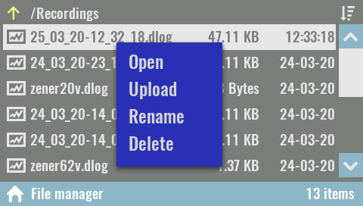
SCPI
MMEMory:UPLoad? {<filename>}

Rename
Rename a file or folder.
SCPI
MMEMory:MOVE {<source>}, {<destination>}

Delete
Deleting a file or folder.

SCPI
MMEMory:DELete {<filename>}

Power outputs coupling  Coupling provides a safe and convenient way to combine power outputs to increase capacity and offer output configurations.  Four power relays are used to combine the power outputs, avoiding the possibility of poor connections or accidental loss of connection, which could have detrimental effects on the connected load. | 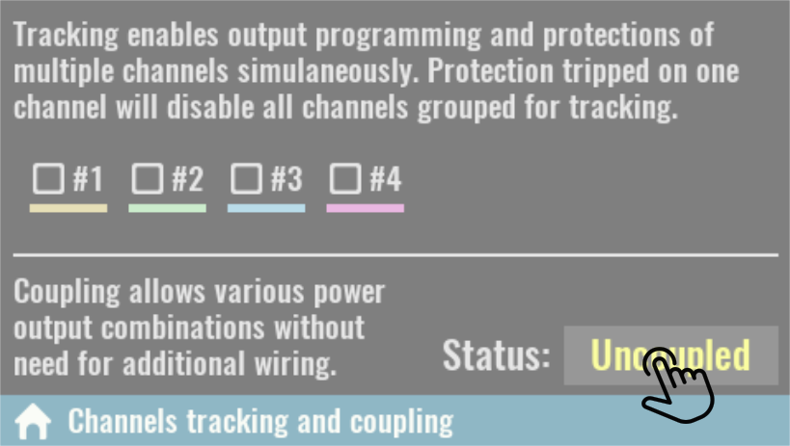
Furthermore, in the case of coupling into series or parallel, when doubling the output values, this will be taken into account, thus avoiding errors in the interpretation of the set and measured values.
By default all outputs are independent, i.e. separated from each other and “floating” or isolated in reference to MCU ground or PE (Protection Earth) potential.

Please note that regardless of the set coupling mode all channel outputs will remain isolated from the MCU ground and PE.

SCPI
INSTrument:COUPle:TRACking NONE

Series  Coupling is series is only possible between DCP405 modules on the first two slots. When coupled, the output connectors of the module in slot 2 will be disabled, and the output voltage on the connectors of the module in slot 1 will be able to be set to twice the value (i.e. 80 V for DCP405).  The maximum output current will remain unchanged (5 A). | 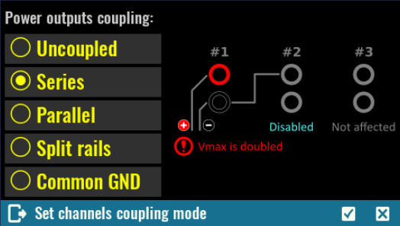
Access to the module in slot 2 will be disabled on display. All set and measured output voltage and power values shown on the display for the module in slot 1 will be doubled.

Please note that according to many standards, voltage of 50 V and above are considered to be hazardous regardless of additional factors such as air humidity and temperature, skin moisture, etc.
Take all necessary precautions when the set output voltage exceeds this value.

SCPI
INSTrument:COUPle:TRACking SERies
Parallel  Coupling is parallel is only possible between DCP405 modules on the first two slots. When coupled, the output connectors of the module in slot 2 will be disabled, and the output current on the connectors of the module in slot 1 will be doubled (i.e. 10 A for DCP405).  The maximum output voltage will remain unchanged (40 V). | 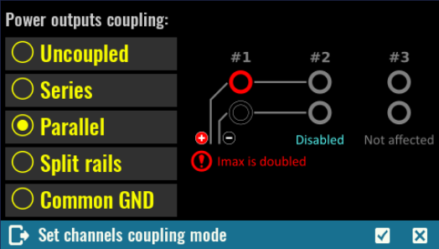
Access to the module in slot 2 will also be disabled on display. The set and measured output current and power values shown on the display for the module in slot 1 will be doubled.

SCPI
INSTrument:COUPle:TRACking PARallel

Split rails  This type of coupling is similar to serial coupling except the output of both channels is still active and the coupling between the first and second channels is used as a common ground. In this way, a symmetrical output is obtained where Vout + of the first channel represents a positive rail and Vout of the second negative rail. | 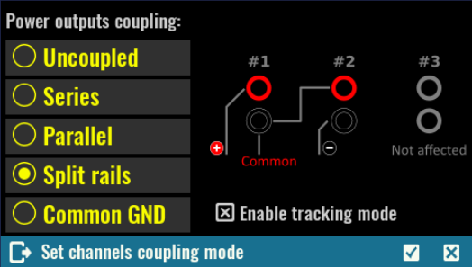
Channels can still be individually controlled, but since this configuration often requires the same output values (e.g. for powering operational amplifiers) a default is offered that places these two channels into a tracking group.

SCPI
INSTrument:COUPle:TRACking SRAil

Common GND  This is the simplest way of coupling the output and results in the connection of Vout- all channels on all slots to a common potential.  As mentioned in the beginning, the Vout- coupled output potential will still not be at the MCU ground or PE potential.  This coupling is not required for Vout- connections between two channels on the DCM220 because they are already internally connected. | 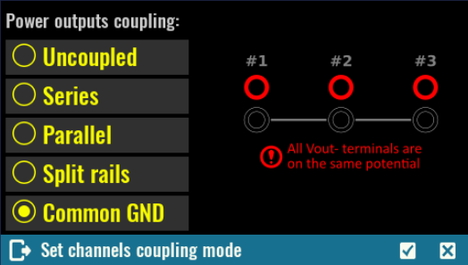
SCPI
INSTrument:COUPle:TRACking CGND

User profiles
User profiles are used to store and recall system parameters and parameters of installed modules.  There are 10 profiles available that are displayed by number and name.  The profile 0 has a special status, i.e. it contains the current parameter states. Its name cannot be defined, but when a recall is made from a profile, it will receive its name.  SCPI  MEMory:STATe:CATalog? | 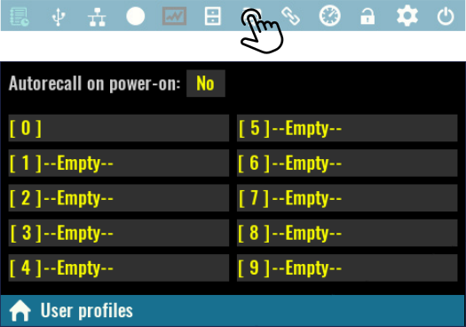

Autorecall on power-on  Defines whether or not to load parameter states from the selected user profile at power up.  When selected, a Power-on profile number is also displayed, that is set by default to user profile 0.  If this option is off, the power up parameters will be set to initial values (i.e. “factory settings”).  Parameters stored in an empty user profile cannot be selected as an auto-recall profile. | 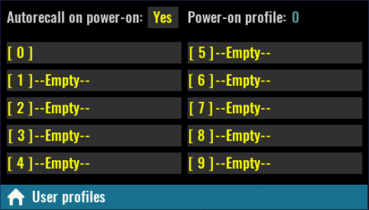
SCPI
MEMory:STATe:RECall:AUTO ON

Save  Saving the parameter state can be done in an empty user profile or one that has already been used.  The following system states and parameters will be stored in non-volatile memory at the position of the selected user profile:  - Calibration status  - Output enable state  - Output track state  - Channel coupling state  - Remote sense state | 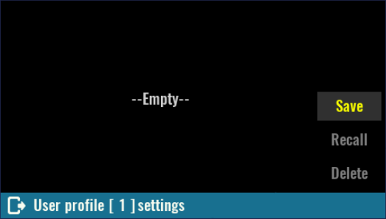
- Output set voltage, voltage limit, and voltage step
- OVP status, and OVP delay
- Output set current, current limit, and current step
- OCP status and OCP delay
- Output power limit, OPP level, OPP status and OPP delay
- OTP level, OTP status and OTP delay
- Power on state
SCPI
*SAV {<profile>}

When saving a user profile, it is necessary to define its name (i.e. Remark as shown on next picture). In case of saving to an empty user profile, the name will be offered as a combination of Saved at and the current date and time. If saved to previously used profiles, an existing name will be offered.  SCPI  MEMory:STATe:NAME {<profile>}, {<name>} | 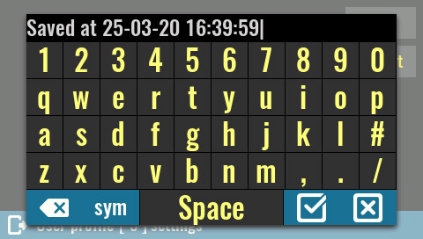

Use as Power-up profile  Specifies whether the initial states will be loaded or not from the profile if the Autorecall on power-on option is selected.  SCPI  MEMory:STATe:RECall:SELect {<profile>}  Recall  Use this option to load immediately the parameter status from user profile. | 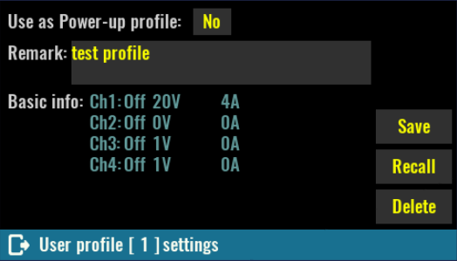

SCPI
*RCL {<profile>}

Delete
Empty user profile and reset its name (remark) to –Empty--.

SCPI
MEMory:STATe:DELete {<profile>}

Display lock / unlock  Tap the lock icon to lock display. When locked the icon changes color and lock state is saved in non-volatile memory. Therefore, the front panel remains locked even after power is cycled.  SCPI  SYSTem:KLOCk  Unlocking is performed by tap on the lock icon, and may require system password for unlock if it is defined.  SCPI  SYSTem:LOCal | 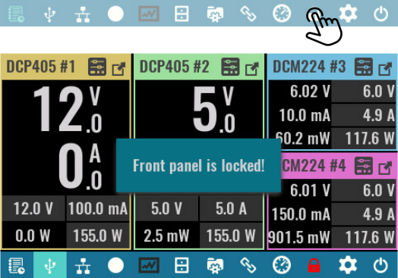

Power / reset control  Default (*RST)  Initiate so-called soft reset procedure. All outputs are set to OFF, and voltage and current are programmed to 0.  SCPI  *RST  Standby  Results in disconnecting of AC power for all installed peripheral modules. | 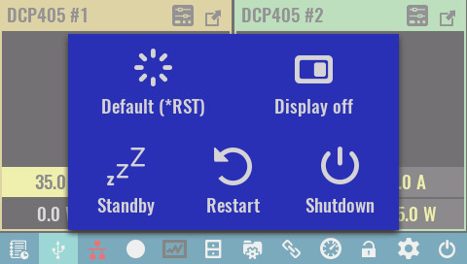
Standby mode keeps the MCU module powered that is indicated with the Standby indicator on the front panel. The power up can be initiated by tap and hold action anywhere on the screen.

SCPI
SYSTem:POWer OFF

Restart
This action is equivalent to recycling input power. On power up all modules will be initialized, self test will be performed and initial values will be set depending on the selected user profile and Autorecall on power-on status as defined in User profiles.

SCPI
SYSTem:RESet

Shutdown
Initiates a graceful shutdown that ensures that the latest information are stored in non-volatile memory. Wait until a message appears on the screen that EEZ BB3 can be safely turned off.

Display off
While the display is off, future user interaction will be disabled until it is turned on again. Turn the display back on by tap and hold action anywhere on the screen.

SCPI
DISPlay OFF

User SW  None  If selected, no function is assigned to the user switch. A short push of the user switch will open the menu showing available options. Press the button once again if no changes is needed.  Once an option is assigned to the user switch it will be necessary to press and hold the button for about 1 second for the menu to reappear. | 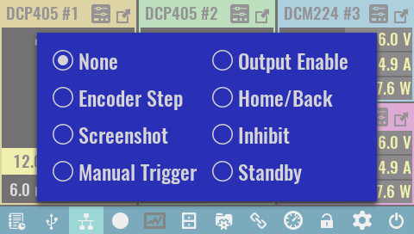
Encoder Step
Cycle through the sensitivity of the encoder to change the selected output value (voltage, current or power). Initially, the encoder is set to Auto mode when the change will depend on the speed at which it will rotate. Its turn sensitivity in one direction or the other can be changed in the Encoder settings.

Screenshot
Take screenshots of current screen content and save to SD card in the screenshots folder. The image will be saved in jpeg format and its name formatted as yyyy_mm_dd-hh_mm_ss.jpg

Manual Trigger
Allows the user switch to be used to initiate the trigger system (see General trigger settings).

Output Enable
When two or more channels are in tracking mode, this option allows their outputs to be switched on and off simultaneously

Home/Back
When this option is selected, user switch can be used as an option to return to the previous or main page. It can also be used to exit maximized channel view.

Inhibit  This option is selected by default, when user switch can be used to enter inhibit mode when all active outputs will be temporarily disabled that is indicated by INH text. To exit inhibit mode, you will need to press the button once again.  Standby  If EEZ BB3 is turned on and this option is selected, the first time a button is pressed, it goes into standby mode. The next time the button is pressed, it exits standby mode. | 